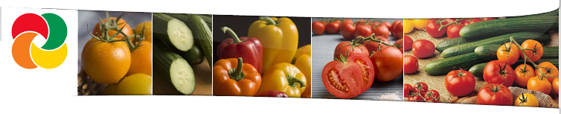

**Food Journal**

|  |  |  |  |  |
| --- | --- | --- | --- | --- |
| Time | Breakfast | lunch | Snacks | Drinks/Carbs |
|  |  |  |  |  |
|  |  |  |  |  |
|  |  |  |  |  |
|  |  |  |  |  |
|  |  |  |  |  |
|  |  |  |  |  |
|  |  |  |  |  |
|  |  |  |  |  |
|  |  |  |  |  |
|  |  |  |  |  |
|  |  |  |  |  |
|  |  |  |  |  |
|  |  |  |  |  |
|  |  |  |  |  |

**Important Notes:** ___________________________________________________________________________________________________________________________________________________________________________________________________________________________________________________________________________________________________

Date: ___ / ___ / ______ Prepared By: _________________________________

Health & Nutritional Consultancy

FOODS FOR LIFE